Chapter 1 The atom
extra worksheet 2:Half-life and carbon dating
Science Inquiry Skills Verbal/Linguistic, Logical/Mathematical, Visual/Spatial
The difference between a stable isotope and a radioisotope is that a radioisotope may undergo a nuclear reaction at any moment, whereas a stable isotope will not.
It is impossible to know exactly when a particular atom of a radioisotope will undergo a nuclear reaction. Only the probability of the nuclear reaction occurring can be known. This probability can be expressed in terms of the radioisotope’s half-life.

Half-life
The half-life of a radioisotope is the time it takes for half of the atoms in any group to undergo a nuclear reaction. It cannot be known specifically which of the atoms will undergo a reaction, but it can be known that approximately half of them will react within one half-life.
For example, if you have 1000 atoms of a radioisotope with a half-life of 5 days, then 500 of the atoms should have reacted after 5 days. The half-life for the remaining 500 atoms is still 5 days, so after another 5 days the number of unreacted atoms will halve again, leaving 250 unreacted atoms. After another 5 days you will have 125 unreacted atoms, and so on.
The percentage of atoms of a radioisotope that remain unreacted after a certain time can be calculated using the equation:
Percentage of atoms remaining = 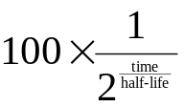

Carbon dating
Scientists can use the half-life equation to calculate the age of old artefacts or fossils in a process known as carbon dating. To do this, scientists measure the amount of the radioisotope carbon-14 in the artefacts. The half-life of carbon-14 is 5730 years, so the percentage of carbon-14 remaining in an artefact changes over time according to the equation:
Percentage of atoms remaining = 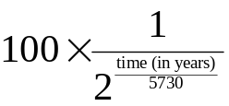
Living things constantly replace their carbon atoms, so the proportion of carbon-14 in a new object is always the same. By comparing the amount of carbon-14 in an old artefact with the amount in similar materials today, scientists can calculate the artefact’s age.
1 Use the equation for the half-life of carbon-14 to complete the tables below.
Time (years) | 0 | 5000 | 10 000 | 15 000 | 20 000 | 25 000
Carbon-14 remaining (%) | 100 | 54.6 | 29.8 | 16.3 | 8.9 | 4.8

Time (years) | 30 000 | 35 000 | 40 000 | 45 000 | 50 000
Carbon-14 remaining (%) | 2.6 | 1.4 | 0.8 | 0.4 | 0.2
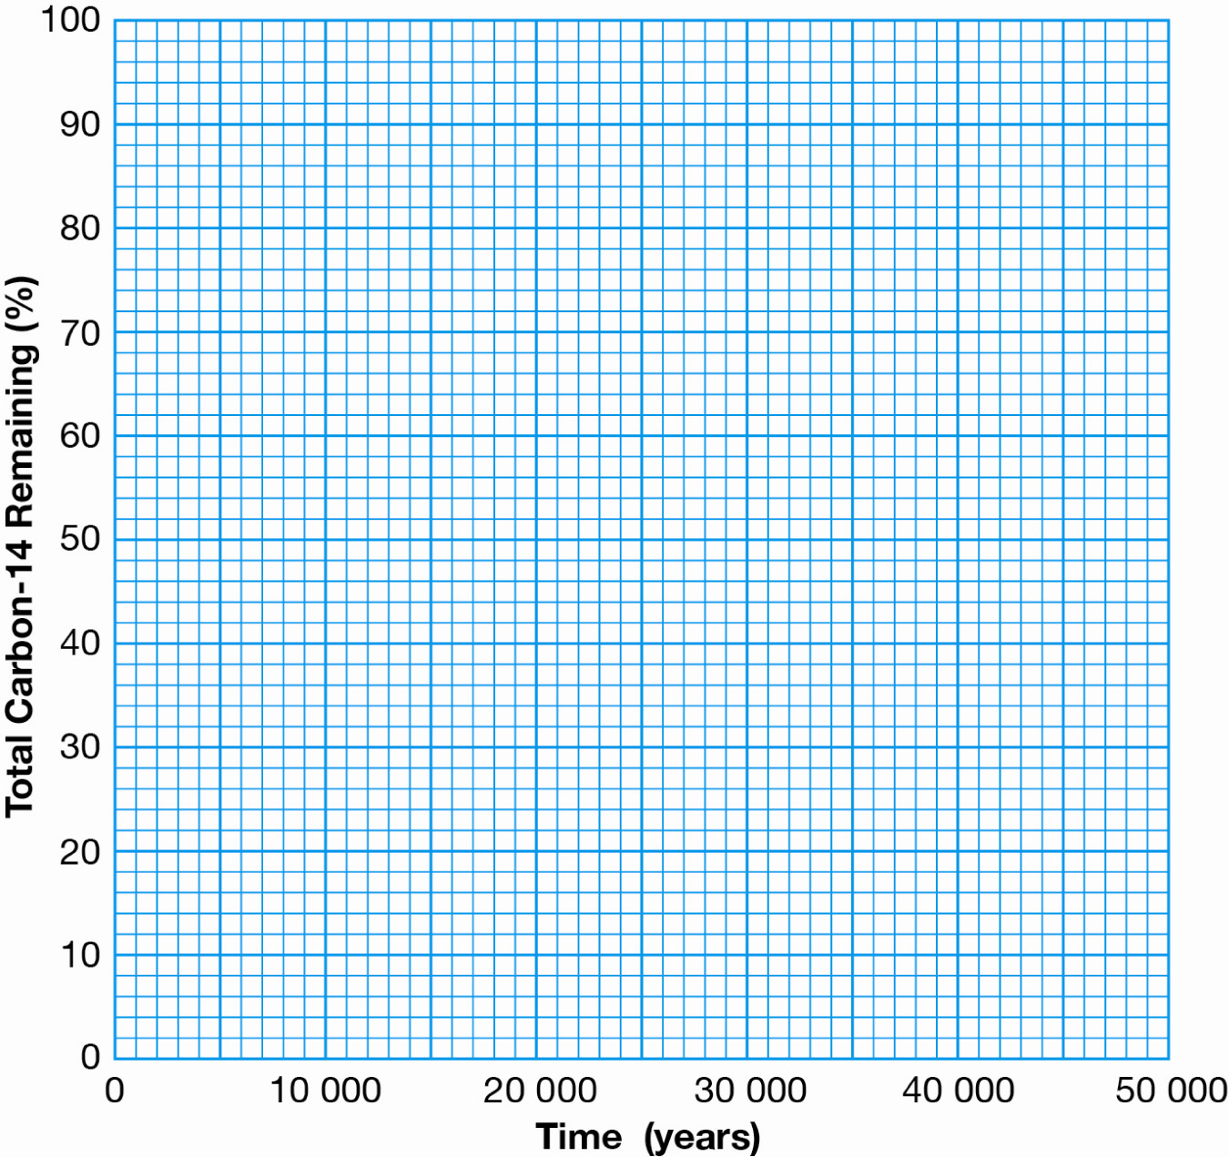
2 On the axes below, construct a graph of the percentage of carbon-14 as a function of time.

3 Use your graph or the half-life equation to calculate the percentage of carbon-14 that would remain in the following artefacts.
a Papyrus scroll, 4000 years old  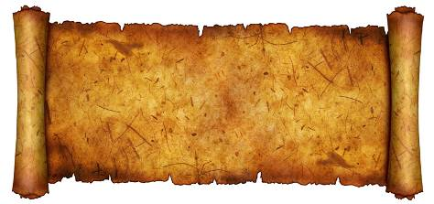  ___ % | b Tree stump, 28 000 years old  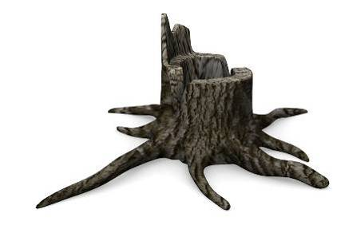  ___ %
c Skull, 17 000 years old  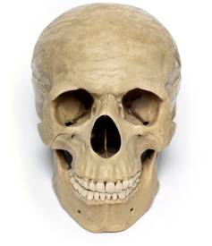  ___ % | d Hatchet, 2000 years old  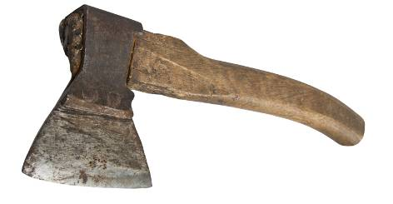  ___ %

4 Use your graph to determine the age of the following artefacts to the nearest 500 years.
a Book, 90% of original carbon-14  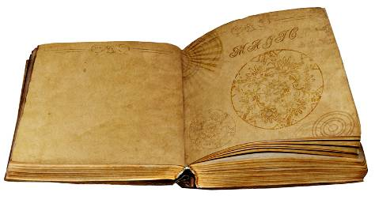  _____ years | b Mallet, 2% of original carbon-14  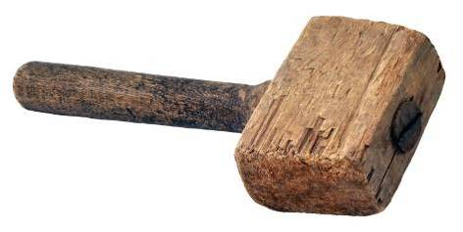  _____ years
c Wooden spoon, 20% of original carbon-14  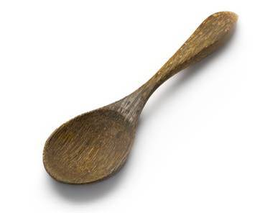  _____ years | d Feather, 44% of original carbon-14  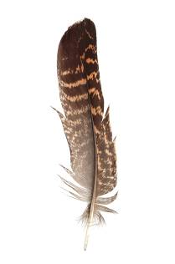  _____ years

